Joint Actions on Harmonised Products 2020
JAHARP2020-3 [GA SI2.851409]
Work Package (WP) 1 – Gas-Fired Space Heaters
Brussels, 2021.12.17

Invitation to provide information to support the Action and express non-binding interest in the task

Procedure
Please complete Tables A, B and C below and send your response as soon as possible, but no later than 19 January 2022 by e-mail to the PROSAFE Office addressed to Mrs Ioana Sandu, Executive Director, at harp2020@prosafe.org and to Mr Torben Rahbek, PROSAFE facilitator at tr@torbenrahbek.dk, AND to info@prosafe.org.
For any clarification on any aspect of this invitation, please send an e-mail to the above addresses.
- Identity of the laboratory

Name of the laboratory
Address
NB Number
Contact person | Name
 | E-mail
 | Telephone

- Test programme and number of samples

Please propose a summary of a test programme that makes it possible to verify the most important safety features of Gas fired space heaters and with a minimum number of samples to be tested for each model. The products that will be subjected to the tests fall under the three different types mentioned as follows:
Mobile and portable non-domestic forced convection direct fired air heaters | Domestic flueless space heaters (including diffusive catalytic combustion heaters) | Parasol patio heaters
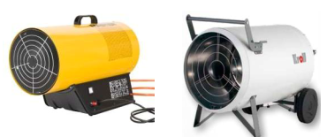 | 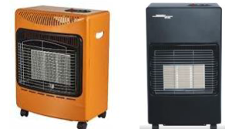 | 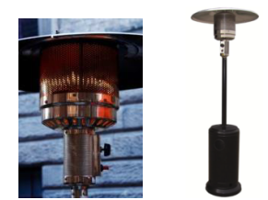
Applicable standard:  EN 1596:1998 including A1:2004 | Applicable standard:  EN 449:2002 including A1:2007 | Applicable standard:  EN 14543:2005 including A1:2007

In principle we plan to test something like 25 to 30 different models of appliances.
The tests should be specified with reference to the relevant clauses of the applicable standard which has been identified as shown in the table above.
An indicative cost for each test should be indicated (non-contractual) excluding VAT.
Test | Standard/Clause … | Number of samples to be tested for each model | Indicative cost (excl. VAT)
Mobile and portable non-domestic forced convection direct fired air heaters | EN 1596:1998 including A1:2004  All Clauses
EN 1596:1998 including A1:2004
Only Clause 7

Domestic flueless space heaters (including diffusive catalytic combustion heaters) | EN 449:2002 including A1:2007  All Clauses
EN 449:2002 including A1:2007
Only Clause 7

Parasol patio heaters | EN 14543:2005 including A1:2007  All Clauses
EN 14543:2005 including A1:2007
Only Clause 8

- Comments or suggestions

Please provide below any comments or suggestions that might help PROSAFE and the project group in the preparation of a Call for Tender.

